Data Cleaning Process
Summary Report — Hospital Admission & Discharge Records
This report documents the data-quality issues found in the raw patient admission/discharge dataset and the cleaning steps applied to resolve them, as recorded in the workbook's Raw Dataset, Cleaning Process, and Clean Dataset sheets.

1. Dataset Overview
The workbook tracks hospital admission and discharge records (patients, wards, sponsors, admission/discharge timestamps, length of stay, discharge outcome, district, and region), predominantly for facilities in the Kigoma region.
Metric | Value
Raw records (Raw Dataset sheet) | 907 rows × 18 columns
Records carried through cleaning workflow | 906 rows analyzed
Final clean records (Clean Dataset sheet) | 905 rows × 12 columns
Sheets in workbook | Raw Dataset · Cleaning Process · Clean Dataset
Table 1. High-level dataset counts.

Raw Dataset — sample
A representative excerpt of the untouched source data:
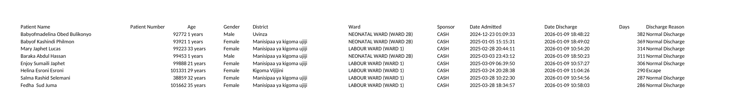
Screenshot 1. Raw Dataset sheet (first rows, key columns).

2. Data Quality Issues Identified
The Cleaning Process sheet runs each raw field through validation and standardization formulas, flagging problems column by column.
Field | Issue Found | Detail
Patient Number | Duplicate IDs | 44 of 906 rows share a Patient Number with another row (flagged "Duplicate"); 862 are unique
Age | Mixed units in one field | Stored as free text such as "1 years", "11 months" — not usable for numeric analysis
Gender | Inconsistent labels | Checked for values outside "Male"/"Female"; all 906 rows passed as Valid
District | Spelling/naming variants | 11 raw spellings collapsed to 10 standardized names (e.g. "Manisipaa ya kigoma ujiji" → "Kigoma Ujiji Mc"; "Buhingwe" → "Buhigwe")
Ward | Free-text ward/room labels | Long raw labels (e.g. "FEMALE SURGICAL & GYNECOLOGICAL WARD (WARD 5)") mapped to 11 standardized ward categories
Sponsor | Unstandardized categories | UNIQUE() inventory of column M surfaced 9 distinct payer categories (CASH, NHIF, NSSF, MHIS, FAST TRACK, CHF, OTHER INSURANCE, STRATEGIES, and one facility code)
Date Admitted | Text, not real dates | 904 of 906 rows stored the timestamp as text ("Text Error"), blocking date math and sorting
Date Discharge | Mostly valid | Already numeric/date in nearly all rows; a standardized "Clean Discharge" column was produced
Days (length of stay) | Checked for errors | Row-by-row check: validated as numeric and non-negative — all 906 rows OK
Discharge Reason | Category inventory | UNIQUE() inventory of column W surfaced 5 categories in use: Normal Discharge, Escape, DAMA, Death, Referred
Region | Outlier values | UNIQUE() inventory of column Y surfaced 3 distinct regions: Kigoma (904 rows), Katavi (1), Tabora (1) — the 2 non-Kigoma rows were flagged for review
Table 2. Issues identified per field.

3. Cleaning Methodology
Each field was cleaned with a dedicated formula placed in an adjacent helper column (headers highlighted in green), so the original raw values are preserved side-by-side with the corrected values. Below, each formula is shown in its own box, with the plain-language explanation directly underneath it — so you can read what a formula literally does, and what it means, as two separate things.
Two different validation techniques appear in the workbook:
- Row-by-row checks (Patient Name, Patient Number, Age, Gender, Days) evaluate every single row and return a per-row verdict, e.g. "OK" / "Text Error" / "Negative".
- Category-inventory checks (Sponsor, Discharge Reason, Region) use a single UNIQUE() array formula placed once in row 2 that spills down and lists every distinct value found anywhere in that column, rather than flagging individual rows.

Name, ID, age, and gender checks
Patient Name — name-completeness check (column B)
=IF(LEN(TRIM(A2))-LEN(SUBSTITUTE(TRIM(A2)," ",""))>=1,TRIM(A2),"⚠ Only 1 name: "&TRIM(A2))
Trims extra spaces and checks the name contains at least one space (i.e. two or more name parts). If not, it prepends a warning flag rather than silently passing a single-word name through.
Patient Number — duplicate check (column D)
=IF(COUNTIF($C$2:$C$905,C2)>1,"Duplicate","Unique")
Counts how many times this Patient Number appears in the whole column. If more than once, marks the row "Duplicate"; otherwise "Unique". 44 of 906 rows came back Duplicate.
Age — text-to-number conversion (column F)
=IF(ISNUMBER(SEARCH("month",E2)), LEFT(E2,FIND(" ",E2)-1)&"/12", VALUE(LEFT(E2,FIND(" ",E2)-1)))
Pulls the leading number out of free text like "1 years" or "11 months". If the text says "month", it's expressed as a fraction of a year (e.g. "11 months" → 11/12); otherwise the number is taken as whole years.
Gender — validity check (column H)
=IF(OR(TRIM(G2)="Male", TRIM(G2)="Female"), "Valid", "Inconsistent")
Flags anything other than exactly "Male" or "Female" as "Inconsistent". All 906 rows passed as Valid.
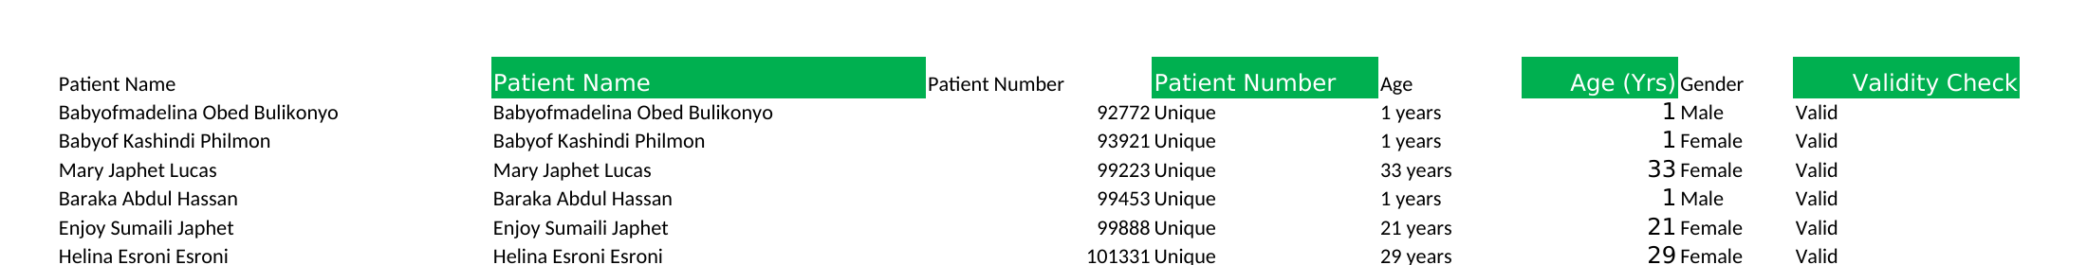
Screenshot 2. Cleaning Process sheet — name, ID, age, and gender columns (before → after).

District, ward, and sponsor standardization
District — spelling standardization (column J)
=SUBSTITUTE(SUBSTITUTE(TRIM(CLEAN(I2)),"Manisipaa ya kigoma ujiji","Kigoma Ujiji Mc"),"Buhingwe","Buhigwe")
CLEAN() strips non-printable characters, TRIM() removes extra spaces, then two nested SUBSTITUTE() calls rewrite the two known misspellings to one standard name each.
Ward — keyword mapping (column L)
=IFS(
ISNUMBER(SEARCH("ICU",K2)), "ICU",
ISNUMBER(SEARCH("NEONATAL",K2)), PROPER("NEONATAL"),
ISNUMBER(SEARCH("LABOUR",K2)), PROPER("LABOUR"),
ISNUMBER(SEARCH("PAEDIATRIC",K2)), PROPER("PAEDIATRIC"),
... (11 conditions total),
TRUE, "Unmapped: " & K2)
Searches the raw ward/room text for a keyword (e.g. "NEONATAL", "LABOUR", "ICU") and returns a short, standardized ward category for the first keyword it matches. A final TRUE branch would label anything unrecognized as "Unmapped" — none occurred, so all 906 rows matched one of 11 categories.
Sponsor — category inventory (column N)
=UNIQUE(M2:M907)
Lists every distinct payer/sponsor value found anywhere in the raw Sponsor column, spilling down from this one cell. Surfaced 9 categories, letting a reviewer eyeball the list for stray or misspelled entries.
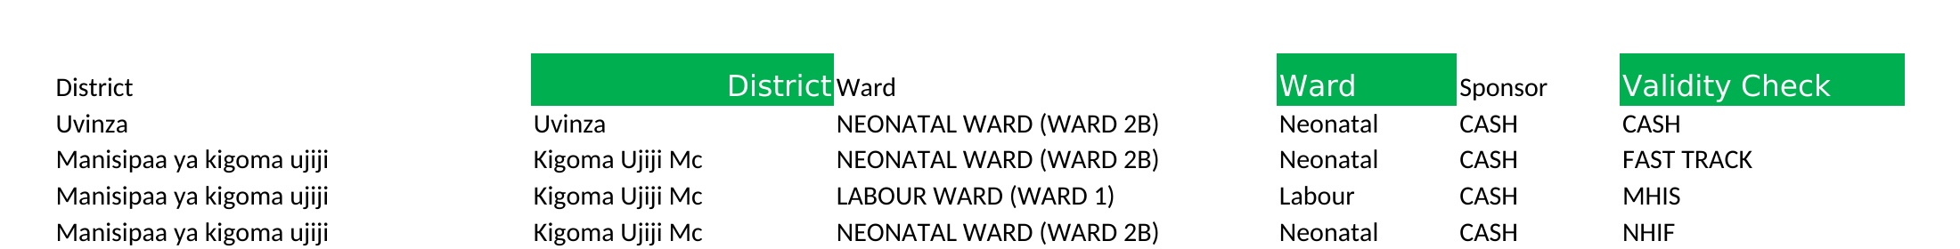
Screenshot 3. Cleaning Process sheet — district, ward, and sponsor columns.

Date and length-of-stay checks
Date Admitted — text-vs-date check (column P)
=IF(ISNUMBER(O2), "Valid Date", "Text Error")
A true Excel date is stored internally as a number; text that only looks like a date is not. This returns "Text Error" whenever the raw cell isn't a real number — true for 904 of 906 rows.
Date Admitted (parsed) — re-check (column R)
=IF(ISNUMBER(Q2), "Valid Date", "Text Error")
The same check applied to a parsed working copy of the date, to confirm the conversion actually produced a real date value.
Days — non-numeric / negative check (column V)
=IF(NOT(ISNUMBER(U2)), "Text Error", IF(U2<0, "Negative", "OK"))
Checks every row individually: "Text Error" if length of stay isn't a number, "Negative" if it's below zero, otherwise "OK". All 906 rows returned OK.
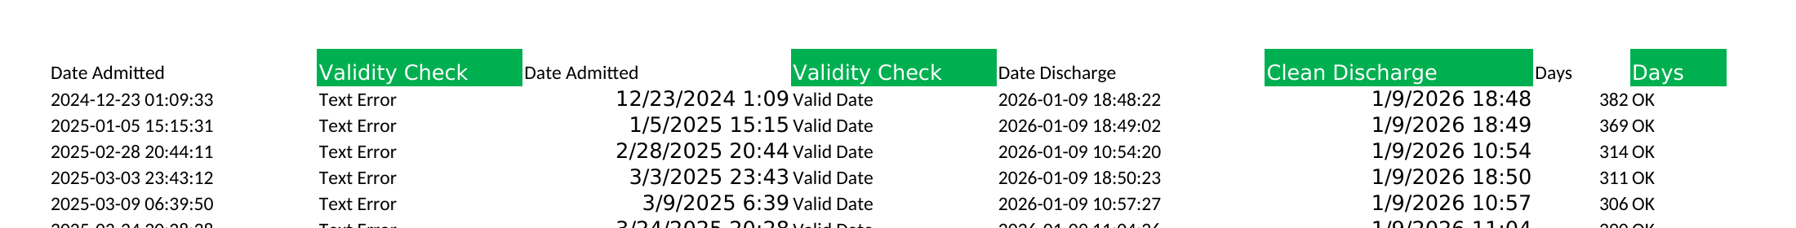
Screenshot 4. Cleaning Process sheet — Date Admitted, Date Discharge, and Days validation.

Discharge Reason and Region checks
Discharge Reason — category inventory (column X)
=UNIQUE(W2:W907)
Spills the 5 distinct discharge reasons found in the raw data (Normal Discharge, Escape, DAMA, Death, Referred) into column X for a quick visual scan — it does not flag individual rows.
Region — category inventory (column Z)
=UNIQUE(Y2:Y907)
Spills the 3 distinct region values found in the raw data (Kigoma, Katavi, Tabora) into column Z. This is how the 2 non-Kigoma rows were spotted — anything other than "Kigoma" stands out immediately in the short spilled list.

Date column fix applied: Text to Columns
The broken Date Admitted column (text instead of real dates) was standardized using Excel's Text to Columns feature, following these steps:
- 1. Select the entire Date column (Column O).
- 2. Go to the Data tab and click Text to Columns.
- 3. Choose Delimited → Next.
- 4. Uncheck all delimiter boxes → Next.
- 5. Under Column data format, choose Date and select YMD.
- 6. Click Finish.
- 7. Format the column as Short Date or a custom YYYY-MM-DD HH:MM:SS format (Ctrl+1).

4. Final Clean Dataset
The Clean Dataset sheet keeps only the corrected values, condensed to 12 columns: Patient Name, Patient Number, Age (Yrs), Gender, District, Ward, Sponsor, Date Admitted, Clean Discharge, Days, Discharge Reason, and Region.
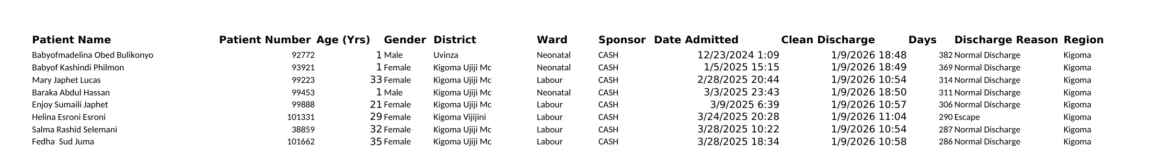
Screenshot 5. Clean Dataset sheet — ready for analysis.

5. Validation Summary
After running every check, each flagged field was reviewed and closed out as follows:
Field | Validation Outcome
Date Admitted | Confirmed broken: 904 of 906 rows were stored as text instead of real dates. Standardized using Excel's Text to Columns feature (Delimited → Date → YMD), converting the column to true date/time values.
Days (length of stay) | Confirmed valid: all 906 rows are numeric and non-negative. No correction needed.
Discharge Reason | Confirmed valid: all 5 categories found (Normal Discharge, Escape, DAMA, Death, Referred) are legitimate, expected values. No correction needed.
Region | Confirmed valid: all 3 values found (Kigoma, Katavi, Tabora) are legitimate entries, not typos. No correction needed.
Patient Number | 44 duplicate Patient Numbers confirmed as readmitted patients — the same patient returning for a separate admission episode — not data-entry duplicates. Retained in the dataset as distinct admission records.
Table 3. Final validation outcome per flagged field.

6. Summary & Recommendations
- The 44 duplicate Patient Numbers are confirmed readmissions, not errors — keep them as separate admission records, but be aware when counting "patients" vs. "admissions" that these represent the same person more than once.
- Date Admitted has been standardized via Text to Columns; re-apply the same check to Date Discharge if it is ever re-entered as text.
- Days, Discharge Reason, and Region all passed validation as-is — no further correction needed for these fields.
- Retain the standardized District, Ward, and Discharge Reason categories for consistent reporting/analysis going forward.
- The Clean Dataset sheet is ready to be used as the analysis-ready source for downstream reporting.

